**MÓDULO 5 – MIC014 – AULA 6**

**Alunos: Wesley Silva Araújo, Lucas Gabriel Rocha Constancio**

**DATA: 14/12/2024**

**Repositório Git:**

**Link:** <https://github.com/lucasrocha777/HandsON-Maloca-das-iCoisas---IOT>

**Alguns commits:**

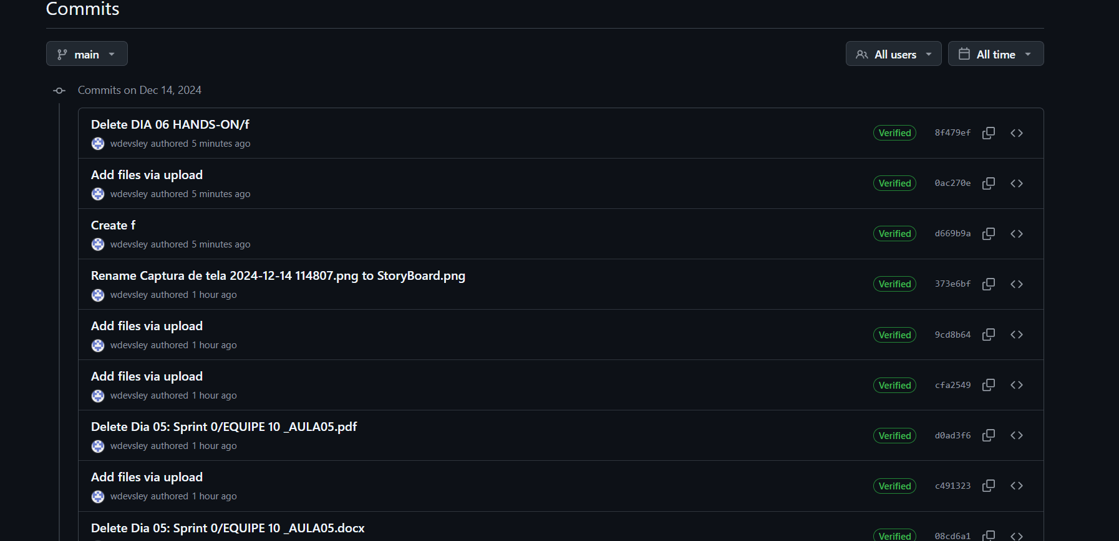

**Kanban:**

**Link:** [**https://trello.com/invite/b/66760ba6cc15ba637d555907/ATTI3c11075f1d955710d36f4ab4a3d9602173C9D877/wesley**](https://trello.com/invite/b/66760ba6cc15ba637d555907/ATTI3c11075f1d955710d36f4ab4a3d9602173C9D877/wesley)